**JSS COLLEGE OF ARTS,COMMERCE AND SCIENCE**

**OOTY ROAD, MYSURU-570025**

**2022-2023**

PROJECT SYNOPSIS ON

“ **PERSONAL CHATBOT OR E-ASSISTANT”**

Submitted by

**Arun Nag Pateel.G.N [JUA20009]**

**Punith.C [JUA20049]**

**Manoj.R [JUA20036]**

**Final year BCA students,**

**JSSCACS,MYSURU**

Under the guidance of

**Mrs. MEGHA**

**Department of Computer Science**

**JSSCACS,MYSURU**

**Signature of Guide Signature of HOD**

**ABSTRACT**

A chat bot also known as a talk Bot, IM bot, chatterbot, Bot, interactive agent, or an Artificial Conversational Entity. Chat bot is a computer program that helps you to communicate via messages. They are formulated to mimic human behavior. They can reproduce exactly how a human would act as a conversational partner. In today’s era almost all tasks are digitalized. We have Smartphone in hands, and it is nothing less than having world at your fingertips.

**INTRODUCTION**

These days we aren’t even using fingers. We just speak of the task, and it is done. It also supports specialized task such as searching anything from Wikipedia and google etc, sending WhatsApp messages and then providing an interface to book an order are helping automate search, discovery, and online order operations. Virtual Assistants are software programs that help you ease your day-to-day tasks, such as showing weather report, creating reminders, making shopping lists etc. They can take commands via text (online chat bots) or by voice. Voice based intelligent assistants need an invoking word or wake word to activate the listener, followed by the command. This system is designed to be used efficiently on desktops. Personal assistant software improves user productivity by managing routine tasks of the user and by providing information from online sources to the user.

**PROBLEM STATEMENT**

As we know Python is an emerging language so it becomes easy to write a script for Voice Assistant in Python. The instructions for the assistant can be handled as per the requirement of user. Speech recognition is the process of converting speech into text. This is commonly used in voice assistants like Alexa, Siri, etc. In Python there is an API called Speech recognition which allows us to convert speech into text. It was an interesting task to make our own assistant. It became easier to send emails without typing any word, searching on Google without opening the browser, and performing many other daily tasks like playing music, opening your favorite IDE with the help of a single voice command. In the current scenario, advancement in technologies are such that they can perform any task with same effectiveness or can say more effectively than us. By making this project, I realized that the concept of AI in every field is decreasing human effort and saving time.

**OBJECTIVE**

Main objective of building personal assistant software (a virtual assistant) is using semantic data sources available on the web, user generated content and providing knowledge from knowledge databases. The main purpose of an intelligent virtual assistant is to answer questions that users may have.

**The main objectives are as follows,**

1. To login using high security (Face Unlock).
2. To capture screenshots and control volume.
3. To search anything from wikipedia, google maps, etc.
4. To view weather, news, set timer.
5. To perform math calculations, sentence translation.
6. To Do List.

**EXISTING SYSTEM**

In the existing System we must enter the search criteria manually and though there are many assistants you cannot modify according to your needs due to present commands given by the developers.

**DISADVANTAGES OF EXISTING SYSTEM**

* But for using these assistants one should have an active internet connectivity to create an account (like Google account for Google assistant, Microsoft account for Cortana).
* And can use it with internet connection only because these assistants are going to work with internet connectivity.
* They are integrated with many devices like, phones, laptops, and speakers etc.

**PROPOSED SYSTEM**

To design a device that acts as a digital organizer to provide variety of services to its master. It will look at examples of intelligent programs with natural language processing that are currently available, with different categories of support, and examine the potential usefulness of one specific piece of software as a Personal chat bot assistant. It continues to expand its digital abilities in organizing events, Search anything from Wikipedia, google maps, In-built search image display Smart Dictionary Search. It is suggested that new technologies may soon make the idea of personal Assistant Chatbot a reality. Experiments conducted on this system, combined with user testing, have provided evidence that a basic program with machine learning algorithms in the form of a digital personal assistant. Using machine learning algorithms to iteratively learn user’s preference for each theme based on quality feedback given by the user. The concept of a virtual assistant which is a digital service looking after a range of our needs is fast becoming a reality. As artificial intelligence and machine learning progress at pace, digital assistants are set to become our gateway to the internet and know more about us than we do ourselves.

**ADVANTAGES**

* Chat bot can gather information efficiently and accurately.
* Saves Time, assigning repeated tasks to virtual voice assistants frees up the human time and resources. They also perform these mundane tasks more efficiently than the humans
* Chat bot have 24/7 Availability, This means that chat bot can answer user queries whenever user have queries.
* These digital voice-enabled assistants also make the operations hands-free. You don’t need to touch any screen or type in anything.

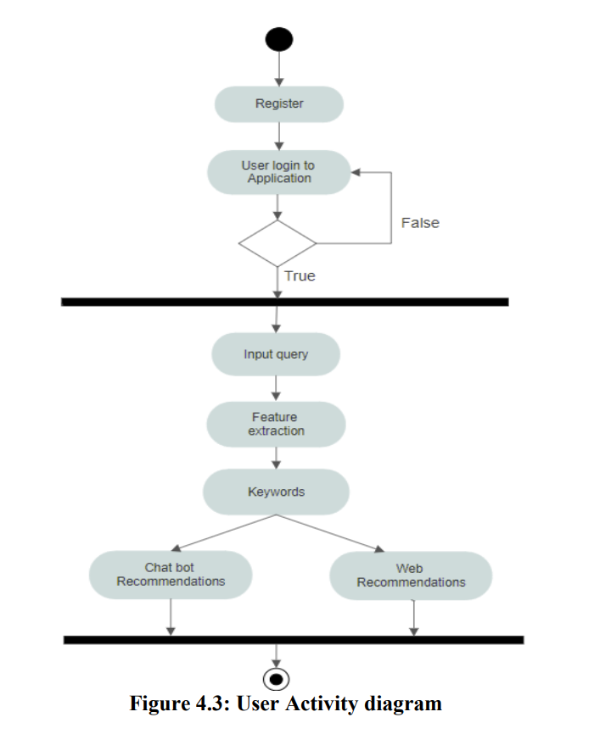**ACTIVITY DIAGRAM**

Activity diagrams are graphical representations of workflows of stepwise activities and actions with support for choice, iteration and concurrency. Different symbols are used to represent activities. As the system is started, it first authenticate the authorized user, then voice assistant is on running in the background listening for available voice commands; once the user gives a command, based on the conditions provided to the voice assistant, the voice assistant gives the necessary output extracting the information from within application or web recommendations. This output is sent to the Speech Recognition which converts the speech into machine-readable form. Based on the input received the Eassistant chatbot then performs the desired task.

**HARDWARE SPECIFICATIONS**

* Pentium-pro processor or later.
* RAM 1 GB or more.

**SOFTWARE REQUIREMENTS**

## Windows 7(32-bit) or above.

## PyCharm 3.8 or later.

## Visual studio Code.

## 

## CONCLUSION

## The E-Assistant chatbot is built using available open-source software modules with visual studio code community backing which can accommodate any updates in future. The modular approach used in our E-Assistant chatbot makes it more flexible and easier to integrate additional modules and features without disturbing the current system functionaries. It not only works on human commands but also it is designed for give responses to the user based on query being asked or the words spoken by the user such as opening tasks and operations. E-Assistant chatbot can be used to not only to chat and get information but it takes artificial intelligence in a whole new light. The main advantage of a chatbot is that it can provide services at any given rate. They respond immediately to the user’s demands with precisely relevant information. This enhances the rate of the communication operation. In simple terms, chatbots make our services faster and as a personal assistant it is the best. The proposed application is used to instantly take screenshots, control volume levels, adding items to list for reminders, language translations and various other reasons

## REFERENCES

[1] Namita Mhatre, Karan Motani, Maitri Shah, Swati Mali, “Donna Interactive Chat-bot acting as a Personal Assistant” in International Journal of Computer Applications (0975 – 8887) Volume 140 – No.10, April 2016.

[2] M. Dahiya, “A Tool of Conversation: Chatbot” in International Journal of Computer Sciences and Engineering, Volume-5, Issue-5.

[3] Carlene Lebeuf, Margaret-Anne Storey, and Alexey Zagalsky, “Software Bots” in IEEE Software, [www.computer.org/software](http://www.computer.org/software).

[4] “How Do Chatbots Work? A Guide to the Chatbot Architecture”, <https://www.marutitech.com/chatbotswork-guide-chatbot-architecture/>.

[5] Gk_, “Soul of the Machine: How Chatbots Work.”, <https://medium.com/@gk_/how-chat->

bots-workdfff656a35e2.